Peter McCall
PLNT 4790
Karibu Kenya: Culture and Agriculture in Kenya
One year ago as a high school senior, I took an environmental science class. In this class, I not only learned about different methods of sustainable farming—such as intercropping and drip irrigation—but also learned of other countries’ population demographics. I was even assigned a third world country research project, and it just so happened to be Kenya. Despite knowing that it was the size of Texas and had over thirty million people, I actually knew very little about what life really like there. I especially had no expectations of traveling there only months into the future.
Kenya was a very enlightening experience for me, to say the least. As a mere freshman who has never been out of the country, I was thrown into a completely new world, and learned so much about its agriculture and culture.
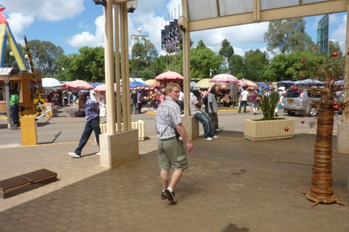
The first day in Kenya was astounding, especially since we had just visited a wild game orphanage, and got “permission” to pet juvenile cheetahs. But then I had to learn a new trade that is widely common in most third world countries—bartering. Being white-skinned and unprepared for street commerce, I was suckered into buying things, some of which I didn’t even want. I would stand there in the hot sun and argue high/low deals on a piece of newspaper. It was even more difficult because I was using a different currency for the first time. As soon as the venders saw how much Kenyan shillings I had stuffed in my wallet, they immediately charged about ten times as much as the product was worth. Worst of all, if I tried reasoning with them, they would react with emotional disappointment. My worst purchase was my drum (called a djembe), because though it was actually worth about fifty U.S. dollars, I later calculated that I paid $175 in shillings. But as hurtful and embarrassing as it was, I learned so much that day. I was by myself in a foreign market having conversations with people about goods and culture. I learned some new words in Swahili; “Simba” coincidently means “lion” and “Tembo” means “elephant.” I also learned that when you see a picture of an elephant with its trunk down it means “peace” and when its trunk is curved back and raised in the air it indicates “good luck.” The market was filled with people, including some innocent white tourists. Venders of all ages had all their jewelry, wood carvings, banana husk paintings, spears, knives, drums, and many other goods displayed on blankets outside in the scorching sunlight. The walkways among each of the stands were crowded yet so narrow one could not help but accidently trample on their goods. The first full day was an intimidating and difficult lesson in how to deal with swindlers and others who are in your face forcing you to buy things.
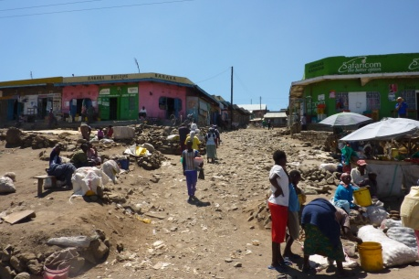
The next day began with an early bus ride to several farms, starting with a prison on the outskirts of Nairobi. But before we learned some agriculture, I was amazed by the culture outside my bus window. It was the most disturbing bus ride I’ve ever been on. The main way of travel for most Kenyans was on foot, so the roadsides were just as crowded as the roads themselves. To my surprise, almost everyone dressed in nice business attire, even though some of them did not fit. Still, they walked around in the red earthen mud in their business shoes. The more fortunate Kenyans would pack into small vans that would take them into town. Still, some actually had their own cars—even nice ones like Mercedes Benz and Range Rover. Many others would ride broken-down bicycles and motorbikes. We even saw one guy riding a horse in downtown Nairobi. But it is notable to say that almost all of the drivers—especially in the city—were nuts. Outside our bus window, all one can see was poverty. The streets were horrible—even worse than Laramie in the wintertime. Their construction is slow and very cheaply done. All along the roads even outside Nairobi were groups of cheap shacks that sold practically anything one could get a hold of: shoes, little children’s buckets, sugar cane, bananas, pineapple, dead chickens strung up by the dozens and being transported on wagons or the roofs of cars, used bike tires, homemade charcoal—anything. If not butchered up and hanging in windows, chickens and goats roamed free everywhere, especially where there was no trash. Speaking of trash, they burn it or throw it down by a river—the most environmentally hurtful place to dispose of it. I even saw a dead, bloated, and rotting cat lying on the side of the road. They show no want to take care of their environments.
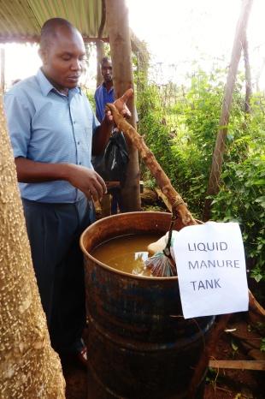
We finally arrived at our first stop: the prison. Boys around the age of seventeen were taken in for six months and taught beneficial skills so they can go back into society and earn an honest living. They used compost, liquid manure for fertilizer, vermiculture, and other simple methods for sustainable farming. Vermiculture is the use of earthworms to help speed up the composting process and produce worm castings, which create some of the best soils for plants to thrive. They used a mixture of compost and manure to make liquid manure by putting it into a porous bag and letting it sit in water. This was called “tea manure” because it was similar to how tea is made. They also taught them how to make shampoo, soap, bleach, detergent, pawpaw jam, seeds, and cordial juice. Apparently it was the largest prison of about 100 prisons in Kenya, holding about 2,800 in its facilities. Yet I worried because the population of Kenya is still over 30,000,000 large, and there is a very high crime rate. With what little resources it had, it seemed a very well-maintained prison.
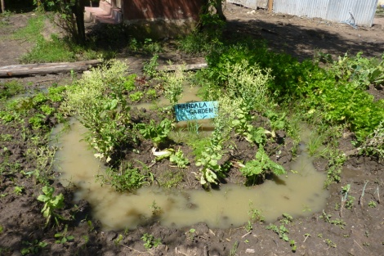
Besides the hope and life skills that the prison was trying to promote for the delinquent young men, we then visited a facility that took in orphans and taught them sustainable agriculture and craftwork. It was called G-BIACK; Grow Bio-Intensive Agriculture of Kenya. I was shocked at how simple yet sustainable G-BIACK’s methods of small-farming were. It was like the gardening I do back home. Some of the unique things they did besides the liquid “tea-manure” was fill a re-used plastic bag with seeds and cut holes in it for plants such as lettuce to grow out of. Another method was a Mandala garden, which was designed in a circular layout where liquid compost and other compost were dumped in the center. The idea is that over time the nutrients spread from that center spot and feed the plants; and all one has to do is consistently water and fertilize that center. It was so similar to that of how some Native Americans used to farm. I also got to see some sustainable farming practices for the first time since I had learned of them in environmental science class. They were using and studying ways of intercropping, and how they can mutually share soil space and nutrients instead of competing. This simple way of planning helped the soil, allowed for more biodiversity for other organisms, and was even timed so crops could have their proper amount of daily shade/sunlight. Outside of the crop production, they also supported a program where someone could have a pregnant rabbit, raise its babies, and keep the net production of their meat as long as they gave back two from the litter. They even practiced beekeeping, which is very beneficial to have around because it helps with crop pollination. Also, girls were taught jewelry making, basketry, and sewing. Of all the interesting things I learned from this small acre facility, I remember seeing a key message of what sustainable farming is all about; “stop growing crops and start growing the soil.” This became such an important theme for the rest of the trip.
After G-BIACK, we visited COSDEP, or Community Sustainable Development Empowerment Program, which was another sustainable farm community. Though they claimed it was healthy, it did not seem like a very hygienic farm, especially referring to the smelly chicken coops that surrounded the farm. One very unique thing that they did was harvest mushrooms in bags inside a dark room.
Finally, after an exhausting day of riding all over the outskirts of Nairobi, we finished the night off at a very fancy yet relaxing restaurant called the Carnivore. Here they served a wide variety of meats sliced off of a sword. I tried beef, chicken, turkey, pork, lamb, crocodile, camel, and (regretfully) ox testicle. It was similar to some kinds of American restaraunts, yet had new and foreign cuisine. Day two was an entirely different view of Kenyan culture and agriculture.
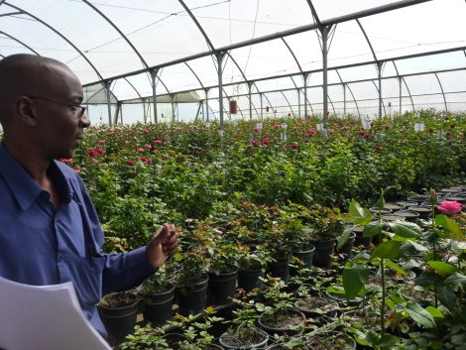
On the third day, we woke up early again and traveled far into the Rift Valley area near Lake Naivasha to a huge industrial facility called Flamingo Flower Farm, which chiefly grew roses and other commercial flowers. In terms of sustainability, this farm was lacking in some aspects. They still fertilized with chemical nutrients and harvested monocultures of roses in semi-indoor buildings. But they were focused on big industry, being able to export to countries such as the U.S., U.K., and Japan. In only about a day, a rose can be transported from the farm in Kenya to a store in the UK, for example. Flamingo Farm grew over forty varieties of roses as well. Though the climate was a great place to grow roses year-round, the soil was one of the problems because it was so silty. They said they did use some methods of composting and other artificial fertilizers to balance this. Another environmental issue they faced is that the LNGG (Lake Naivasha Growers Group) limited their water usage from Lake Naivasha because it was being depleted. So they used more sustainable methods by reusing the water, such as the drain systems at the end of the rows. They used a variety of methods of pest control such as fly traps. They also used mycorrhizas, which Mike explained are a fungal benefactor that improve the soil and roots. They have a high-tech filter system to use to help reuse water, as well as a hydroponics system that could grow plants without soil. They even use artificial wetlands to filter the waste water. But according to Mike and some of our more experienced classmates, this facility was not as great as perceived, because they still wasted on stuff and only used chemical nutrients.
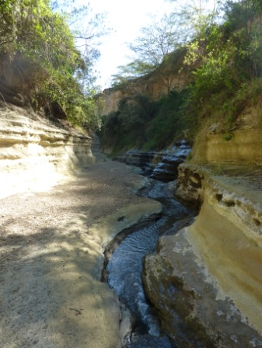
Later that day we traveled to Hell’s Gate. It was a slot canyon carved by and flowing with hot water because the water in that region was from hot springs. This hot water was actually being taken advantage of by geothermal industries. During the drive through we could see white pipelines running out from the hillsides. I could not believe I was seeing so many of the sustainable methods of obtaining energy that I learned of a year ago. Hell’s Gate was very arid and hot, and smelled like sulfur because of the hot springs. We saw a bunch of game when leaving the park: Thompson’s gazelles, impalas, zebras, warthogs (some that were very large), water buffalo, giraffes, etc. They all graze together, and there are just as many seen as on animal planet. It was another exhausting yet amazing day.
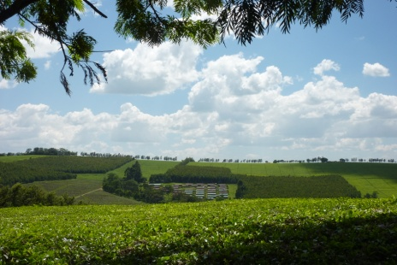
The fourth day was “tea” day. After staying at the Tea Estates Hotel, we first visited the Ketepa tea packaging factory. I could not believe how much tea I was seeing, and still how much more I was about to see. There are about 340 million kilos of tea grown in Kenya each year. 9.5 million were grown at Ketepa. However, only 5% is kept in the country; the rest is exported to places such as Europe and even the United States. Because of the perfect growing climate, it has excellent quality—even Lipton uses it. I had never toured a factory before, and was amazed at how many steps tea went through just to be packaged. They had lots of machines, even a giant magnet to separate the “grains” of tea leaves. They also tested it by mouth sipping and then spitting it out to test the aftertaste as well. Next we traveled to see the endless square miles of tea fields, not to mention the perfectly planted forests of eucalyptus trees used for charcoal and for drying the tea leaves. Unlike the 5 to 7 year life of the Flamingo roses, I was fascinated to learn that tea plants live about 60 to 80 years. Since the 1970s tea plants have been improved by cloning/hybridization, having the ability to yield about 140% as from before. The cost of labor is increasing, though, because of good environmental things like fair trade. Of the two methods of harvesting tea leaves, the handpicking quality was better but the harvesting with the “lawnmower” device was a 25:2 more efficient worker ratio. The farm we visited, Finlays Tea, owned 6000 hectares in 12 separate estates, and housed 13,000-14,000 worker families on the plantation. This extensive region of tea farms where only one crop was efficiently harvested truly defined what a monoculture means.
Days five and six were spent at or near Manor House Agricultural Community. Like the rest of the small farms, almost the entire majority of their food was grown sustainably around the area. Like most parts of rural Kenya, this was essential because there were no grocery stores; what you can grow is what you eat. After we toured the property, we were taught how animal draft power is beneficial in Kenyan agriculture. Donkeys are the draft animal of choice; they are strong, low maintenance, and don’t cause worry about being stolen because they are such a “cheap” animal. It was also interesting how either one, two, or three could be used to haul things. We also participated in making a four-foot compost pile. They make them with layers of corn stalks and other dead crops mixed in with dirt (the dirt contains old native microbes to speed up the process). Manure is also applied to the pile to accelerate the decomposition. The corn and other plants provided a lot of carbon and nitrogen. The importance of moisture for compost is key to its progression, and one must constantly flip it over. The nitrogen cycle is applied here because you want to get nitrate. It receives up to 300cm of rain each year, but much is lost leaching and evaporation. With this large annual rainfall and the temperature inside a pile being about 120 degrees, a good compost pile may take around 4 months to decompose. They also compost like “tea bags” to get liquid fertilizer, the same way the other small farms were doing it. I also learned a new gardening concept: Double digging. The idea of double digging was to maintain the same soil bed layers yet only loosen it so roots can develop better.
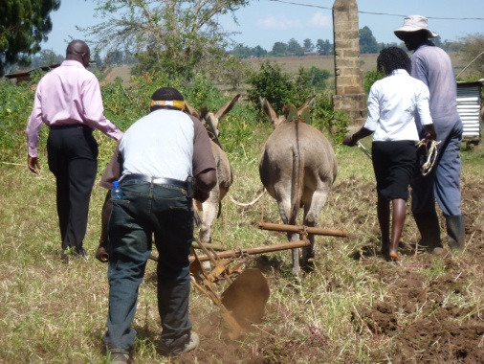
We also visited other farms around Manor House. We visited the Macedonia Self-help Group, who hospitably showed us around and then at the end split up the genders to talk amongst one another to get a view of how life was for men or for women. In experiencing this clash of cultural worlds, it was a very deep and memorable conversation to be a part of. Next we briefly visited (by foot) the Matitsi Women’s Group, and again saw similar crops being grown. It did answer what I had been wondering for a while; where had all of the elderly people, women, and children been, since we mainly saw young men. Knowing that the age of death in Kenya was around forty or fifty, I figured we would not come across very many elderly. We found it amusing that the “herds” of children there only knew one phrase in English—“how are you?!” We then left and visited a good friend of Ammanuel, and toured his small farm as well. It was incredible to see that he was having a new house being built, yet it included no glass windows because it never gets cold enough. This was a characteristic of most buildings in Kenya. While touring that garden, I noticed that they buried pots with holes into the ground and watered them as a way to irrigate the crop-beds. It was a simply ingenious home-made idea. As the day came to an end, we were invited to have fun at Polly’s (an American woman) house farm, where we rode a camel and saw what it could be like to possibly live here as an American. Her house was probably the prettiest of any building I saw on that trip.
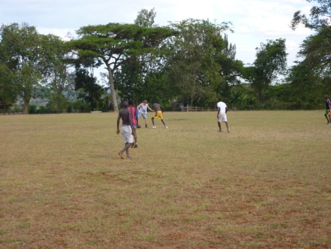
While at Manor House, I had so much fun playing soccer with some of the neighborhood kids that it enriched my viewpoint on what this sport means. It is known as the world’s game, and I couldn’t agree more; give a Kenyan or anyone else in the world a soccer ball and they know exactly what to do with it. I found it awesome how my two favorite teams—Barcelona and Arsenal—appeared the most of any world famous club futbol team on people’s clothes and buildings. The three main soccer buddies I played with were David, Eric, and Armstrong. These guys either work or go to school all day, and then meet and play soccer for two hours until sundown. They didn’t have Xbox or any of that, just a passion for soccer like I do. It’s a sport that brings everyone together for one common experience of fun and bonding. I confidently believe soccer is the strongest weapon in the fight for world peace.
The last three days were spent at the world-renowned Masai Mara National Park. The leisure camp we stayed at was very nice—a completely different way to experience Kenya. On my first official safari we saw wildebeest, warthogs, dic dic, zebra, lion, gazelle, impala, hippo, crocodile, tortoise, water buffalo, ostrich, jackal, and giraffe—so many new wild animals that my eyes were filled with awe. On day two, we also saw golden cat, crocodile, cheetah, elephant, secretary bird, mongoose, lion, baboons, various ungulates, and Masai people, who were the indigenous caretakers of the Kenyan savannah. Some of us, such as Andy and Dave, took some nice quality pictures that could have been used on postcards. Just like a grand slam catch for anglers, safari trips refer to seeing the big five: lion, elephant, rhino, buffalo, and leopard. We saw almost all except the leopard, but that will surely be seen next time. I can only briefly describe Masai Mara, because it is such an awesome experience one must see for themselves.
Though I’m a freshman and know so little information as some of my fellow “Ag” upperclassmen on the trip, I absorbed so much new cultural views and experience, which I feel will benefit me more on my future career. I may not have included as many facts on the agricultural farming aspect, but seeing the many methods of environmentally sustainable agriculture being depended on for survival was incredible. I had never seen so much poverty. Though I felt horrible about losing my money that first day in the Market, I know it went to someone less fortunate than me (I just wish it would have gone to a Kenyan farmer). Though I learned so much about firsthand environmental science, I also saw firsthand poverty. I was taught the phrase “So you say you know the poor? Name them.” Now I have a glimpse of who some of them are. I don’t see this trip as a vacation, but a sneak-peek of all of the world’s problems and lifestyles other than our own. It is up to us, either agriculturally or by some other vocation, to learn from each other in how to coexist with our environment. Kenya was a life-changing adventure.
